User Story-004

Testcase -001 : Functionality Check for cart symbol

Step1: Navigate to the URL of the opencart site 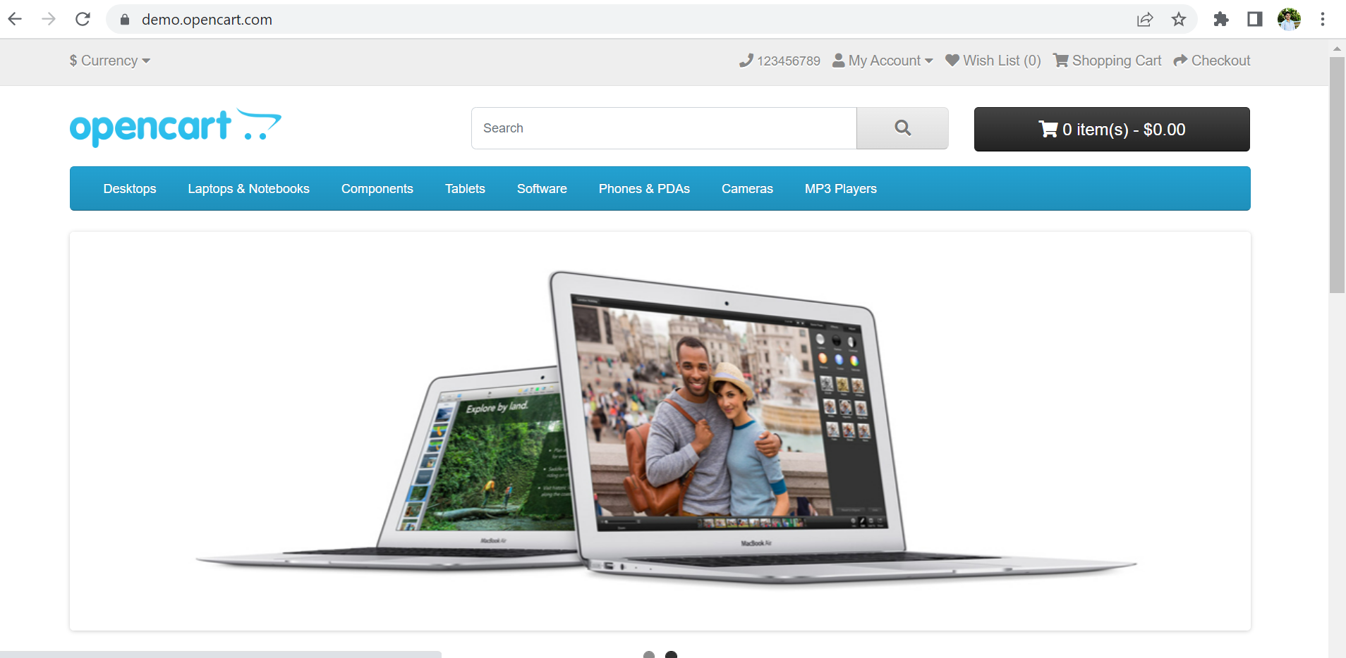

Step3: User should see alert message stating “Please login to continue your shopping”.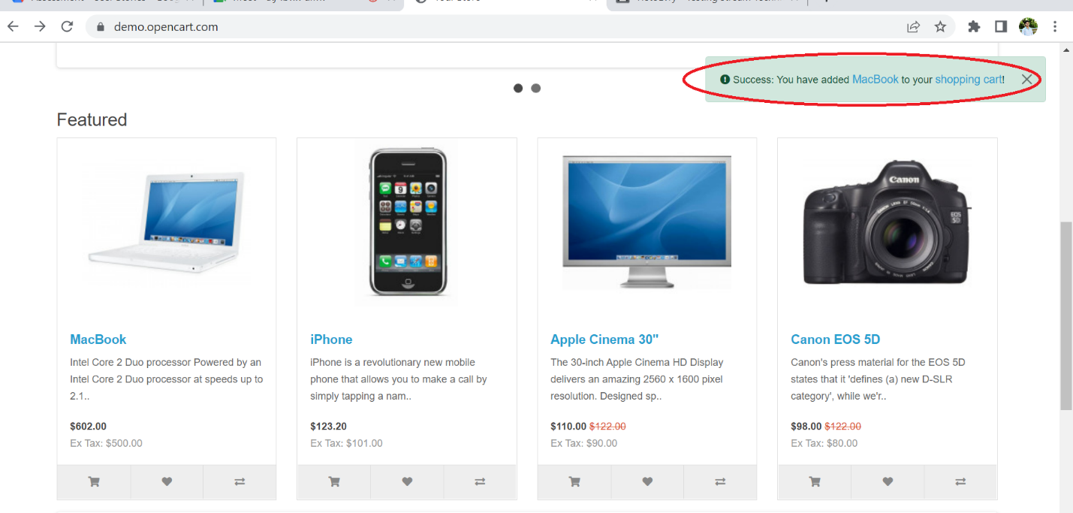

**All the steps are not passed and testcase-002 has a defect as its not displaying alert message as “Please login to continue your shopping”.**